IFB299 Group 96

Car Rental 96 Manual

Car Rental 96

Welcome to Car Rental 96 website!

This is a manual which should help you to utilize the full functionality of the website.

There are step-by-step guides on how to use the distinctive features of the website, along with some example information to put in, to test the website.

Note that the design of the website may be subject to changes, but the functionality should remain the same.

Contents

Creating a User 2

Profile Information and editing 3

Searching for a car 4

Car Recommendation 5

Reserving a car 6

Writing a review 8

Store Interface 8

Data Analytics 10

Data Import from CSV 11

# Creating a User

Once you start the website, click on the register icon in the header to create your user.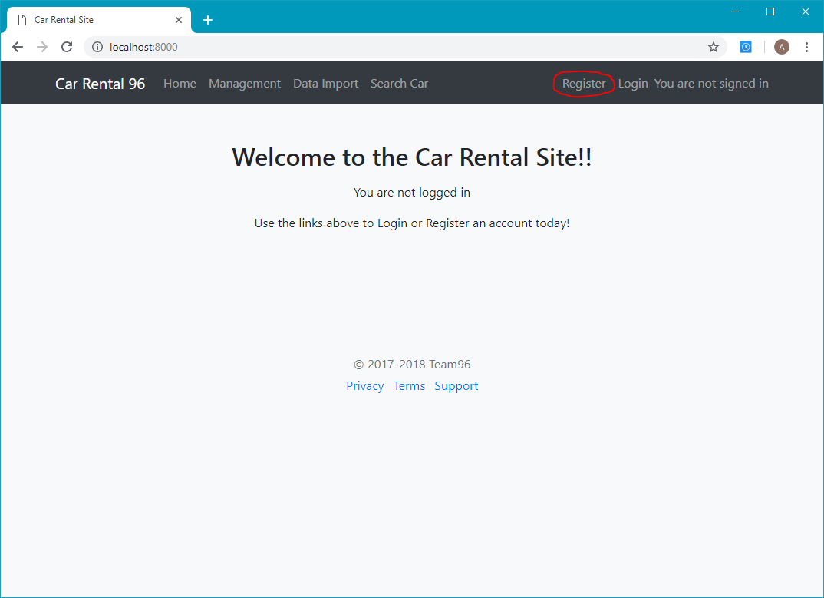

Enter your user details in the forms provided, then click the submit button

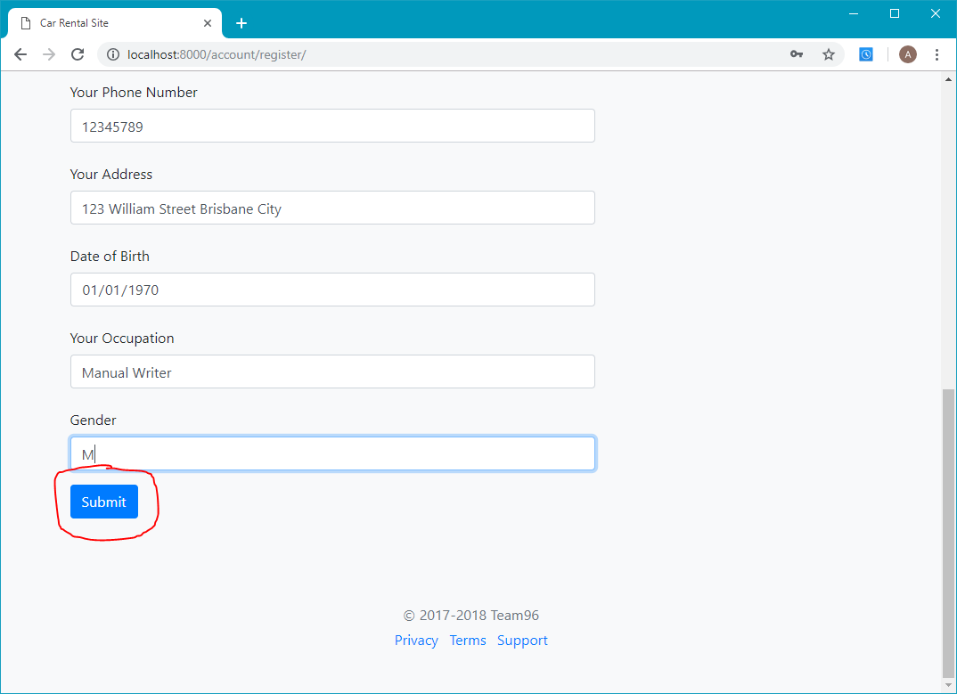

If you entered your information in correctly, you should get the below message. Otherwise, make sure your password is correct, and the other information is valid.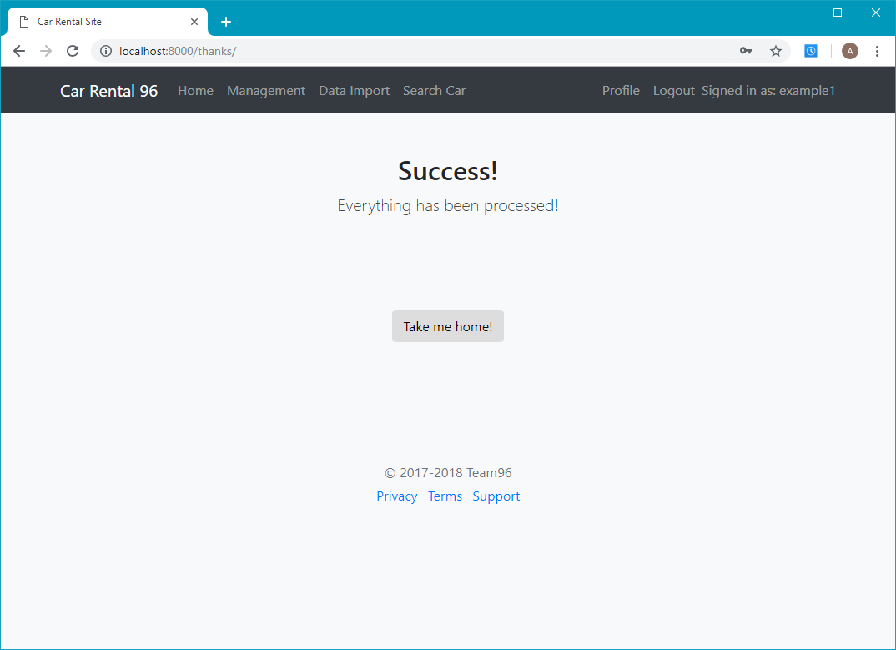

# Profile Information and editing

Once you are signed in, a profile option should appear in the header. Click on this to view your profile.

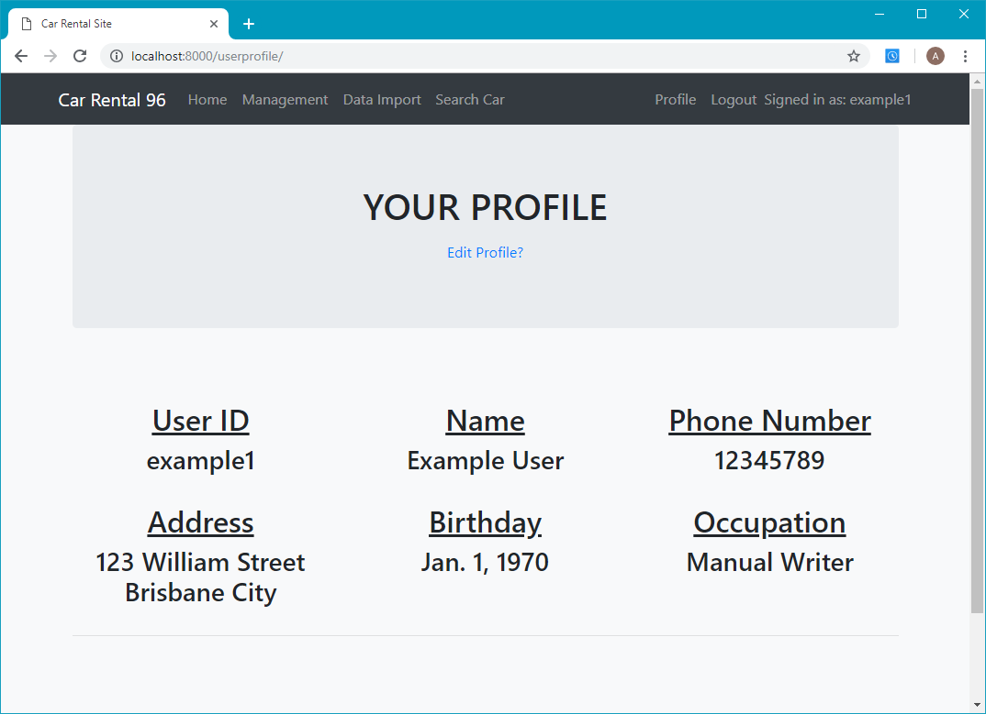

To edit your profile, click the edit profile button. This should bring you to a page like the registration page.

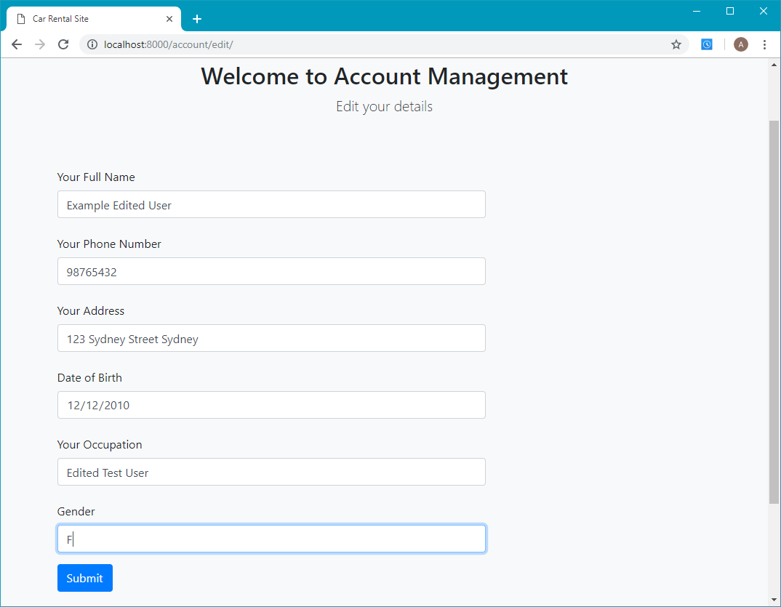

Once you submit your edited information, you should be brought back to the profile page.

# Searching for a car

To search for a car, click on the search car icon in the header

This should bring you to the search page.

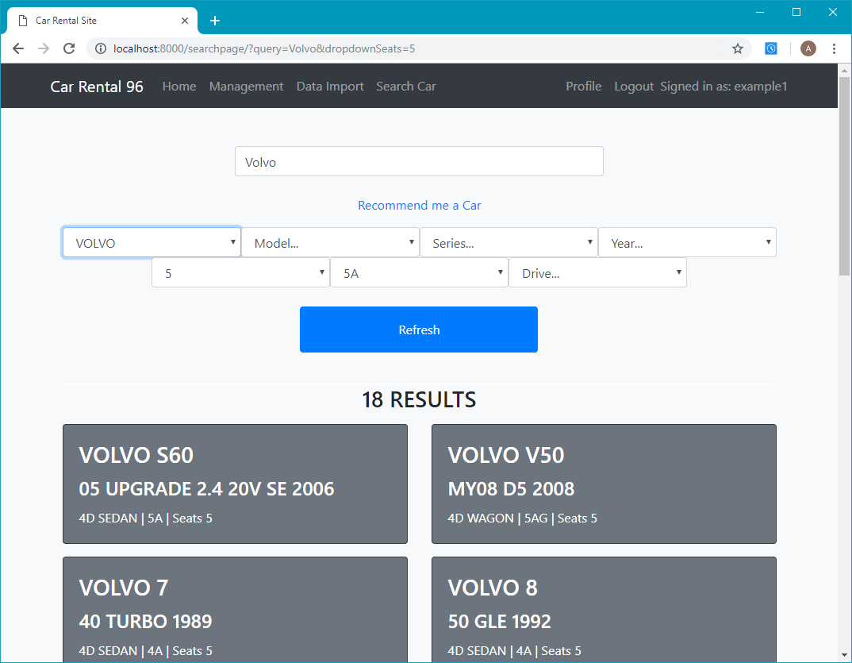

Once you type in what you want into the provided fields, press the refresh button, and relevant results should display, if such cars that match the fields exist.

# Car Recommendation

If you want a car recommended for you, click the recommend me a car button. This should take you to a car recommendations page. Choose whether you want an expensive or cheap car, and how long you are planning to rent the car out for, and it should recommend you a suitable car once you submit the information.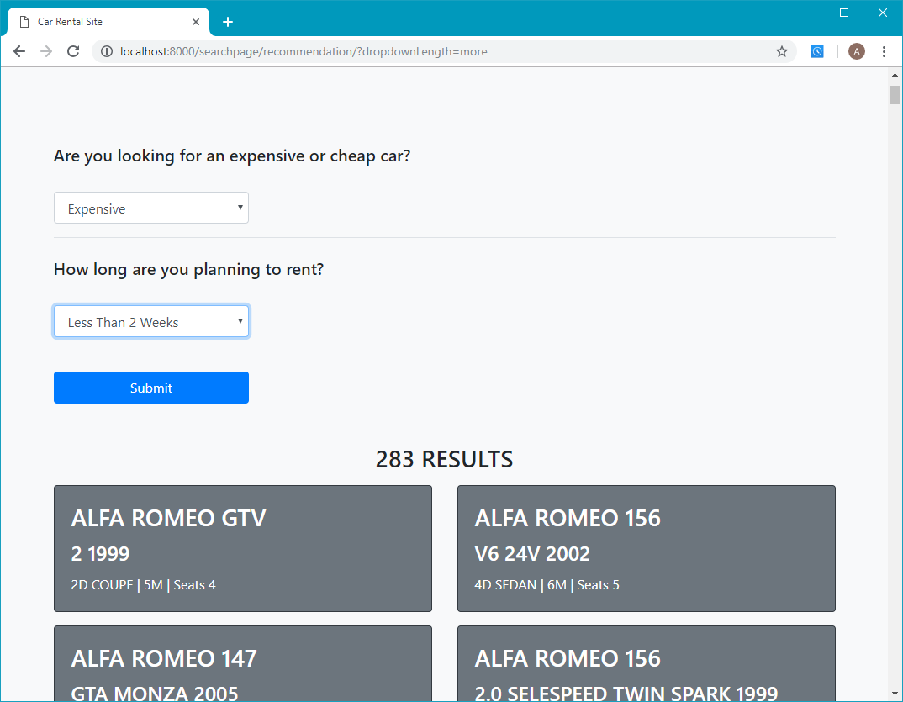

# Reserving a car

Once you have chosen a car to reserve, click on the specific car you want to reserve. This should take you to a car information page.

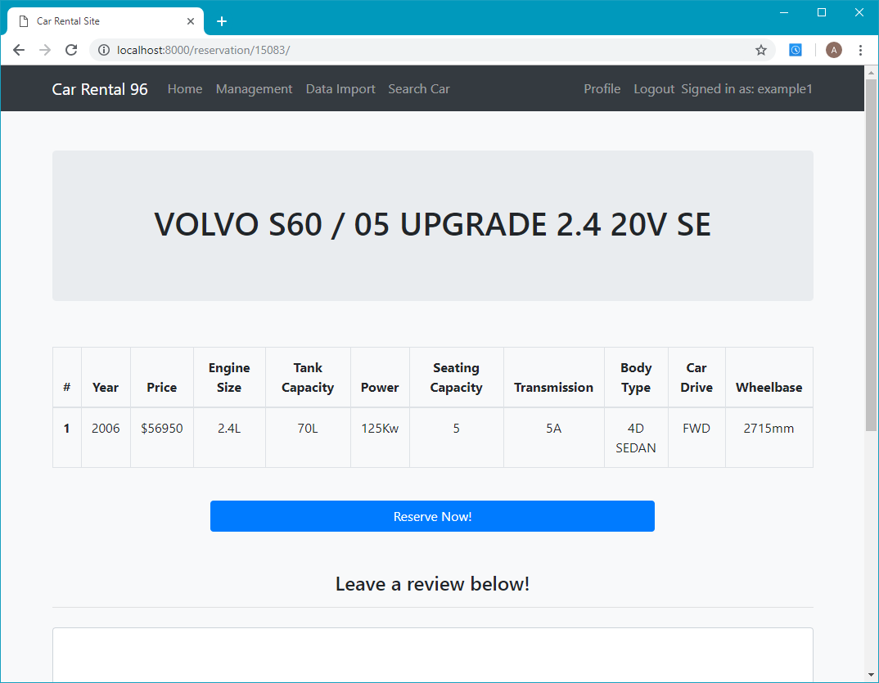

Once you are satisfied the car is a suitable choice, click the reserve now button to reserve the car.

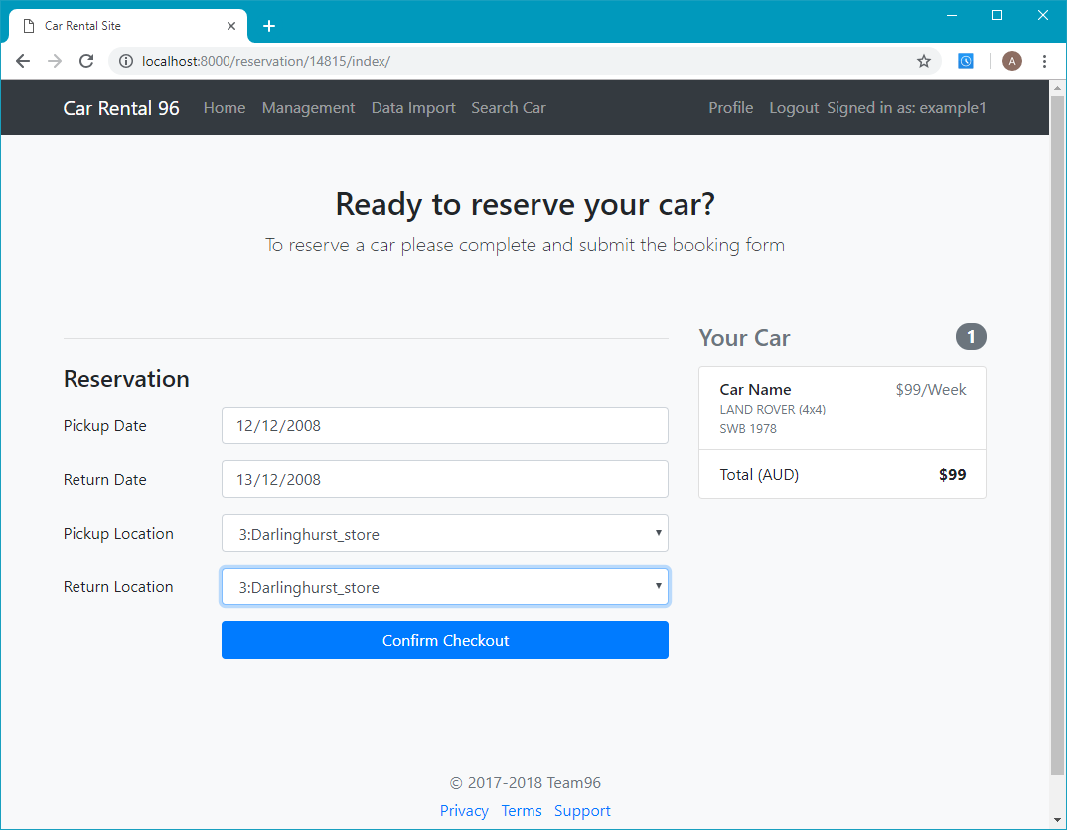

Once you have entered the correct information, the car should be reserved, and you should be taken to a success page

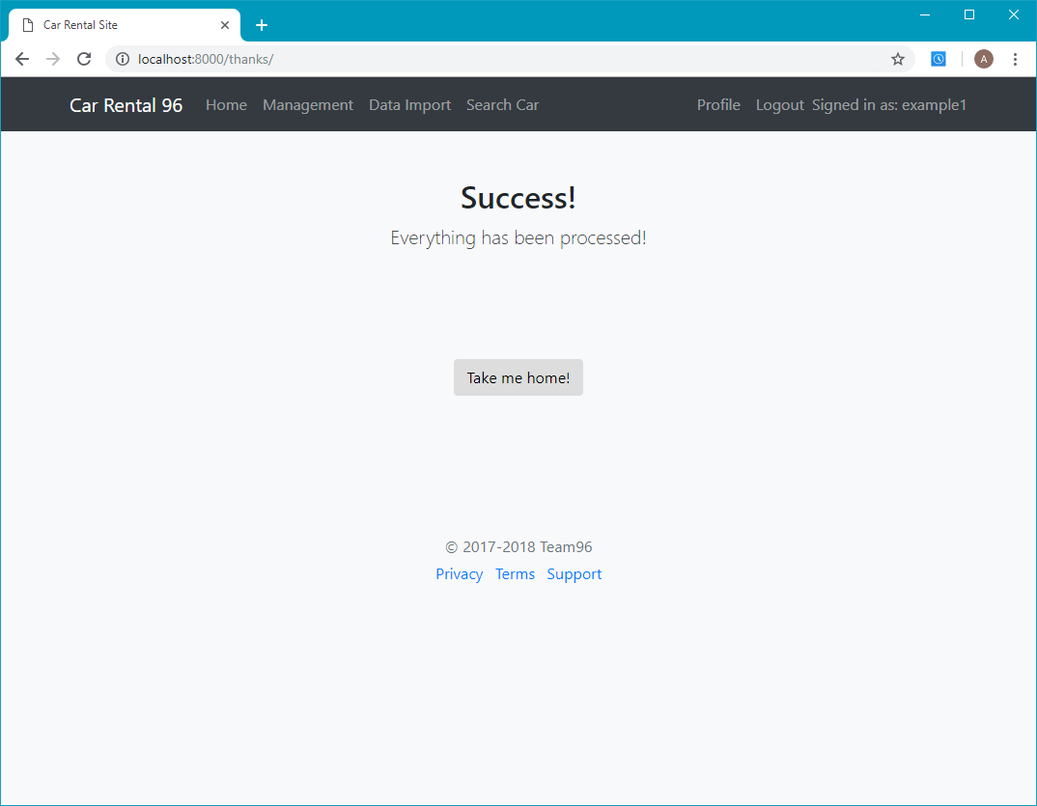

# Writing a review

When you are viewing a car, there should be a review button at the bottom. Enter in your review, then click the submit button to submit your review. The page, once refreshed, should show your review.

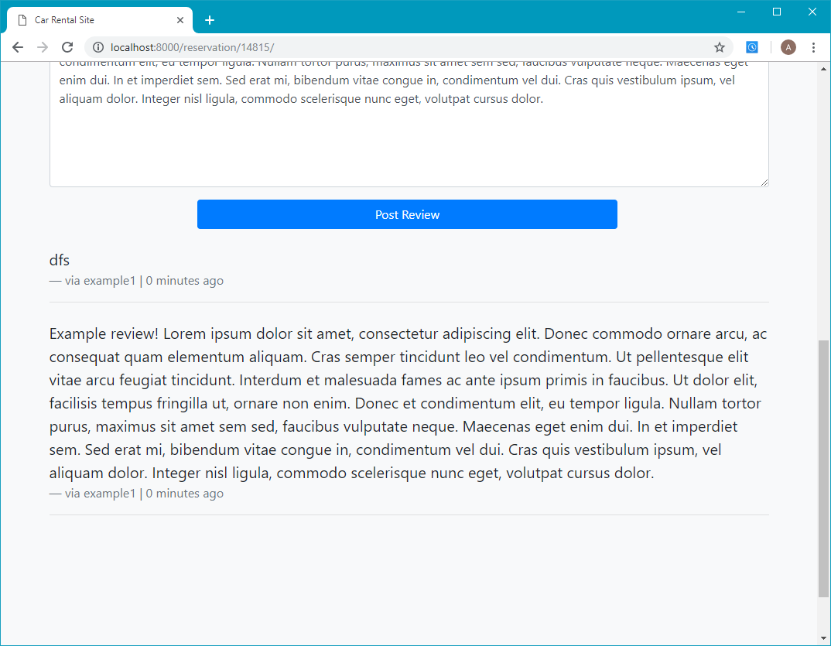

# Store Interface

To Use the store interface, you must be on an admin account. This must be made via the command line. Once you have, click on the management page, in the header. This should take you to a management page.

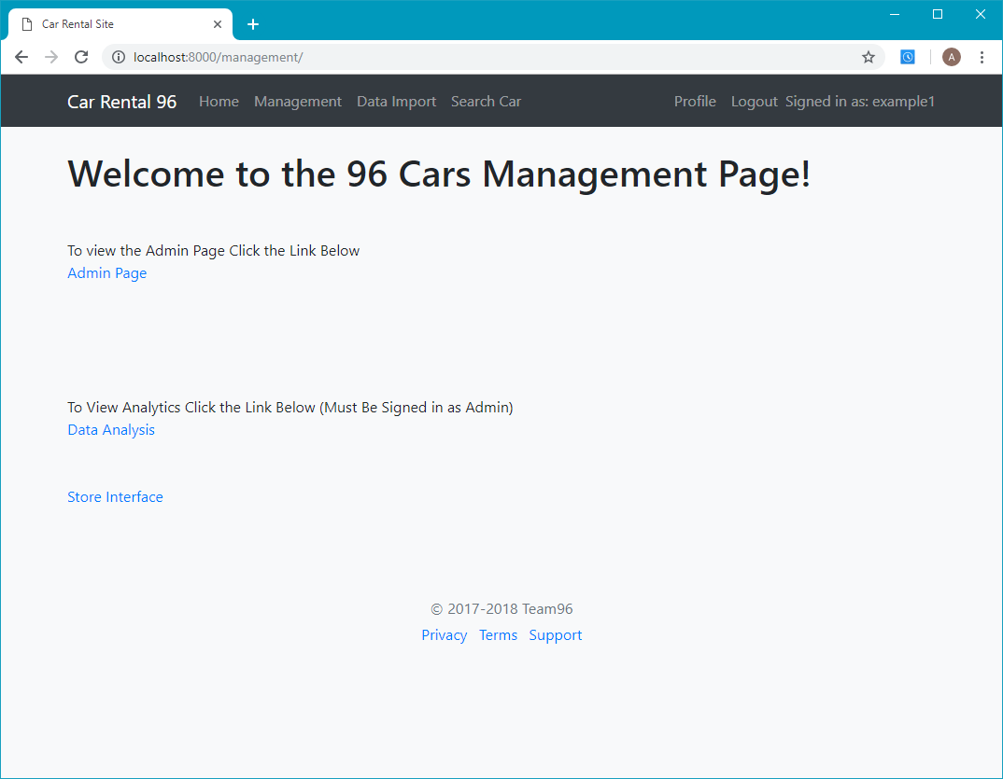

Then, click on the store interface page. This should take you to the store interface.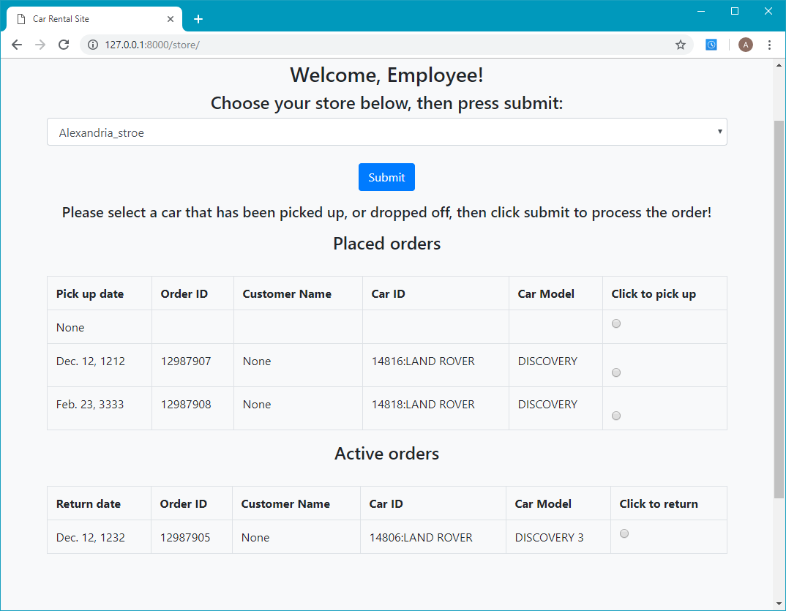

Choose the store you wish to process orders for and click submit. This should display orders specific to the chosen store. To mark an order as picked up, select it in the first table, then click submit. This should move the order to the active order table in the store that it is to be dropped off in. To finish an order (when it is returned), select it in the active order table, and click submit. This should mark the order as finished and return the car to the list of available cars to rent.

# Data Analytics

To view the data analytics, click on the data analytics button in the management page. This should take you to the analytics page. This displays orders from all or a specific store, over a specified time. To choose the specific store, select the first box and choose the store you want to view analytics for, then click the submit button. To choose what time to display the orders over, choose the second box and the time length. If you want to view by year, also pick the specific year. If you want to view it by month, choose the specific year and month, then submit, to see the specified information.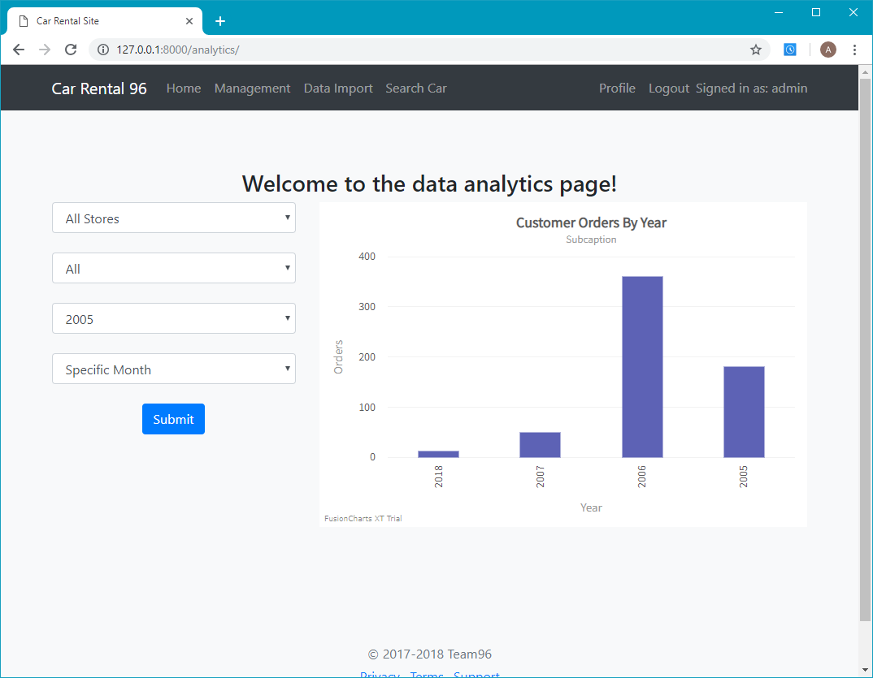

# Data Import from CSV

To import the data from a CSV, choose the data import option in the header. This should take you to a data import page. Pressing the import data button will begin the process of importing the data from the csv provided in the root directory of the project. This will take a while to complete, and the only output that will be seen is from the console.